Charles Henderson

Reuel Maddela

Harpreet Sidhu

Activity 6 build from Activity 3

Validation and login errors on login form: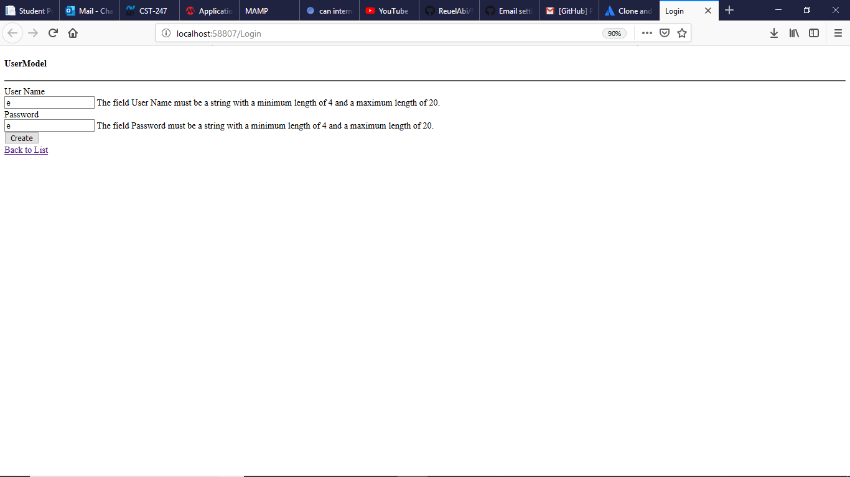

Login Passed form: 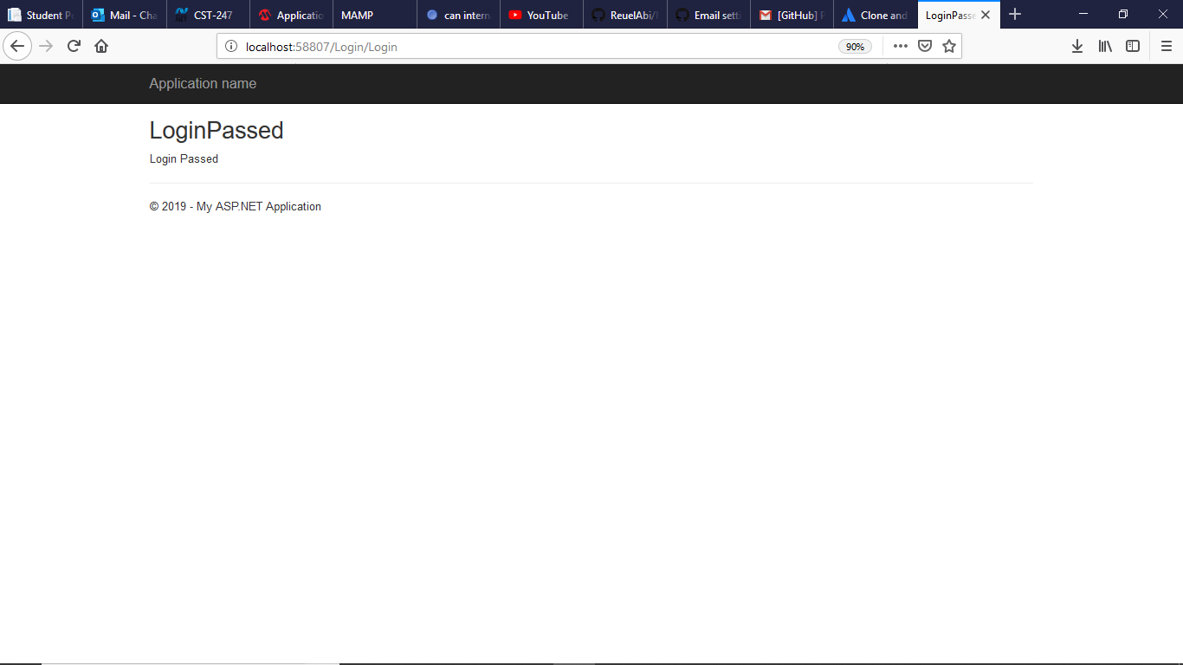

These projects are too large and can’t be uploaded to loudcloud, so the code can be accessed from:

https://github.com/agingdanger/CST-247